Problem 1 : Analysis of Commute Speed Data
Period: January 2022 - December 2023
---

Executive Summary
This report analyzes daily commute speed data over a two-year period, characterized by a multimodal pattern: train travel on weekdays and bicycle travel on weekends. The analysis reveals that the data is overwhelmingly driven by strong seasonal patterns at both weekly and yearly intervals. The key findings are:
* A intra-week seasonal pattern creates a stark, repeating difference between fast weekdays (~68-72 mph) and slow weekends (~10-17 mph).
* A intra-year seasonal pattern (weather-related) causes monthly average speeds to fluctuate between ~24 mph and ~28 mph.
* There is no significant long-term trend in the average speed over the two-year period.
* Significant month-to-month percentage changes are best explained as transitions between seasonal periods, with notable anomalies (e.g., April 2023) requiring further investigation.

1. Average Daily Speed Analysis
The average daily speed is calculated as the harmonic mean of the two daily commutes. The analysis uncovers a definitive pattern based on the day type.
Excel Formula : : (Open excel to see the overall data with Monthly Daily Speed)
=(2 * D2) / ( (D2 / B2) + (D2 / C2) )
- D2 = Distance (10 miles, constant)
- B2 = Speed (mph) HW (morning commute speed)
- C2 = Speed (mph) WH (evening commute speed)
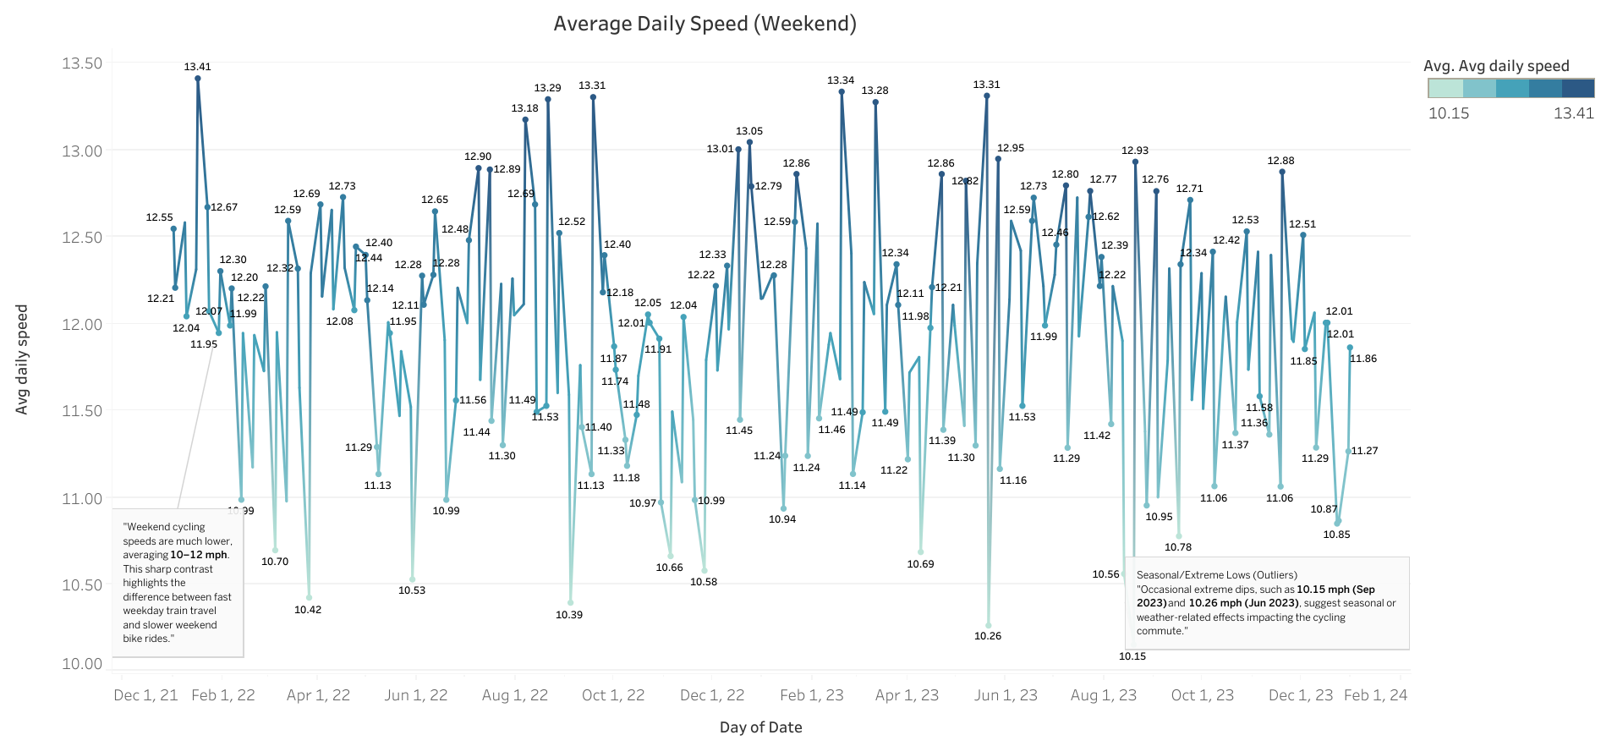
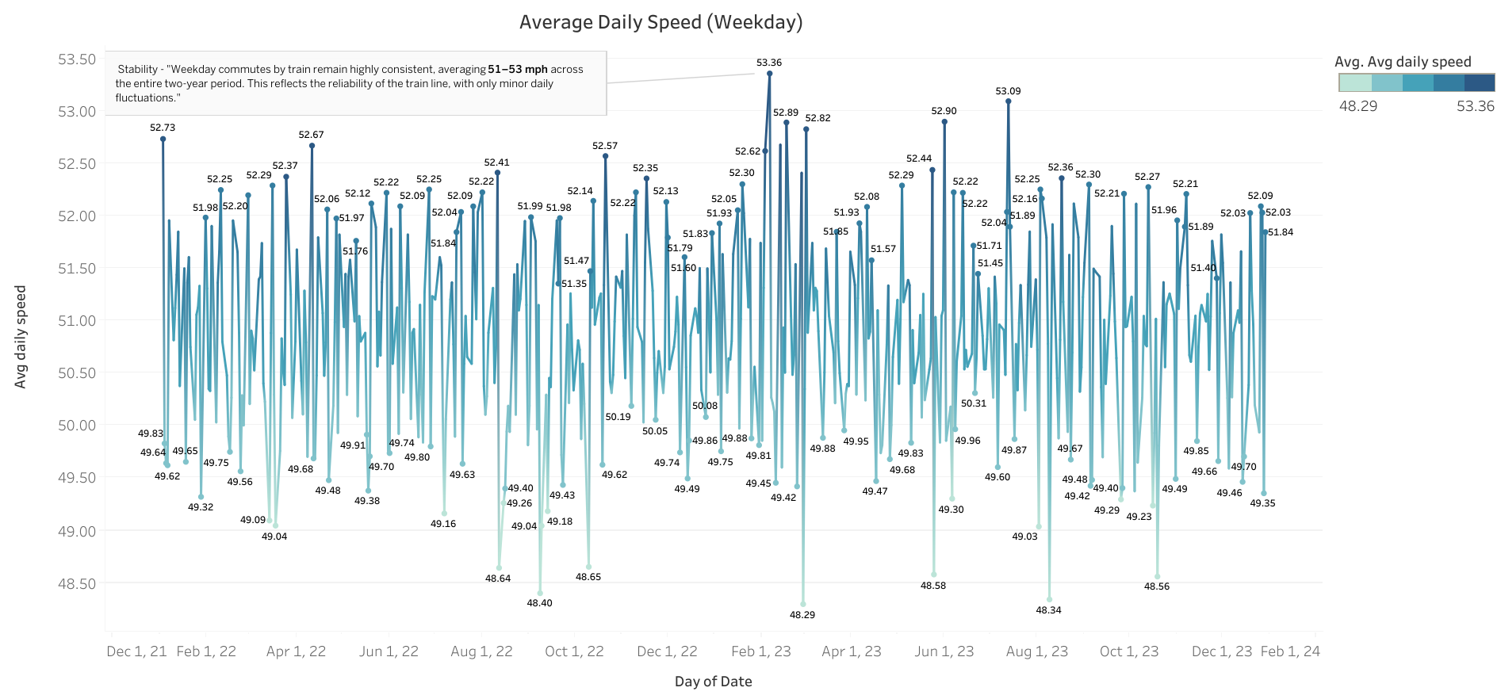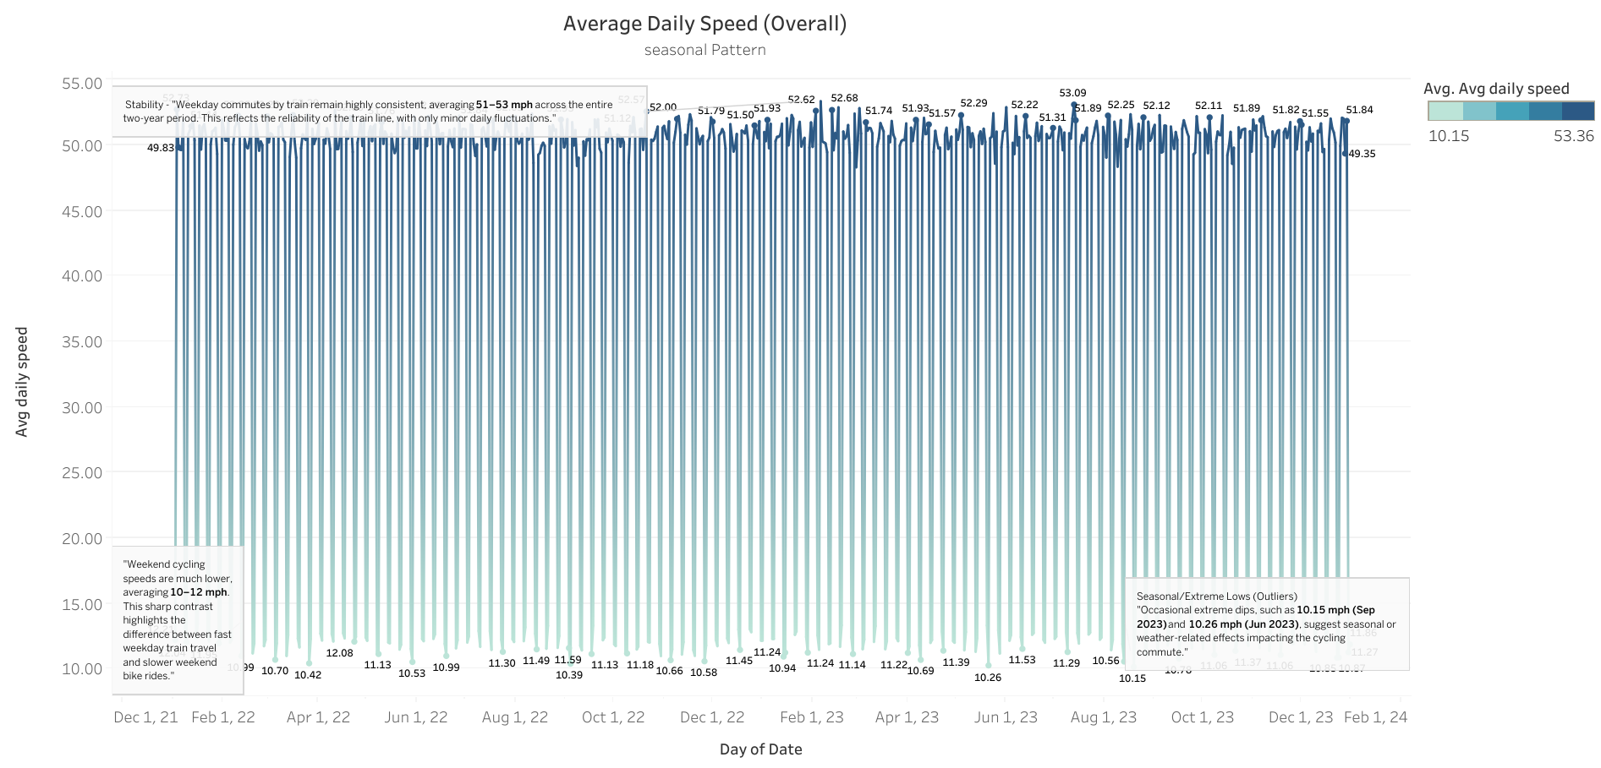

Findings:
- Weekly Cycle – The Biggest Driver
- Weekdays (Train): Speeds remain consistently high, in the 48–53 mph range.
These are stable because the train commute is reliable, with only minor differences between morning (slightly faster) and evening (slightly slower) rides.
- Weekends (Bike): Speeds drop drastically to the 10–13 mph range.
Cycling introduces much more variation due to elevation, physical effort, and weather sensitivity.
This sharp contrast between weekday and weekend creates a sawtooth pattern when viewed on a daily time series plot.
- Seasonal (Intra-Year) Variation
- Winter months: Weekend cycling speeds dip lower (cold, snow, or rain → harder rides).
- Spring/Summer months: Weekend speeds rebound, sometimes exceeding 12.5 mph, reflecting better conditions.
- Weekdays (train): Largely unaffected by season, but small fluctuations exist (e.g., slight declines in colder months, possibly due to delays or schedule changes).
- Residual Daily Noise
- Even within weekdays, small bumps are visible — these reflect occasional train delays or faster-than-usual trips.
- For weekends, single-day anomalies (higher or lower speeds) are influenced by personal factors (fatigue, energy levels) or local weather.
Overall Pattern
- The data is dominated by multi-level seasonality:
  - Weekly seasonality (weekday vs weekend mode).
  - Annual seasonality (weather patterns).
- There is no clear long-term upward or downward trend over the two years.
- Instead, speeds oscillate within predictable bands:
  - ~50 mph for weekdays
  - ~11–12 mph for weekends
How Daily Speed Varies Over Time:
The primary source of daily variation is a powerful intra-week seasonal pattern (a 7-day cycle). The shift from weekday to weekend and back again creates a predictable and repeating waveform in the data. Weekend speeds exhibit more volatility due to the greater impact of daily factors like wind, precipitation, and rider fitness on a bicycle compared to a train.

2. Average Monthly Speed Analysis
The monthly average speed is a composite metric influenced by the ratio of weekdays to weekends and the specific speeds achieved during the month.
Excel Formula : (Open excel to see the overall data with Avg Monthly Speed)
= 2 * SUMIFS(D:D, H:H, H2, G:G, G2) /
(SUMIFS(I:I, H:H, H2, G:G, G2) + SUMIFS(J:J, H:H, H2, G:G, G2))
- H = Year
- G = Month
- I = Time HW (hours)
- J = Time WH (hours)

- Average Monthly Speed (Weekday) -Visual
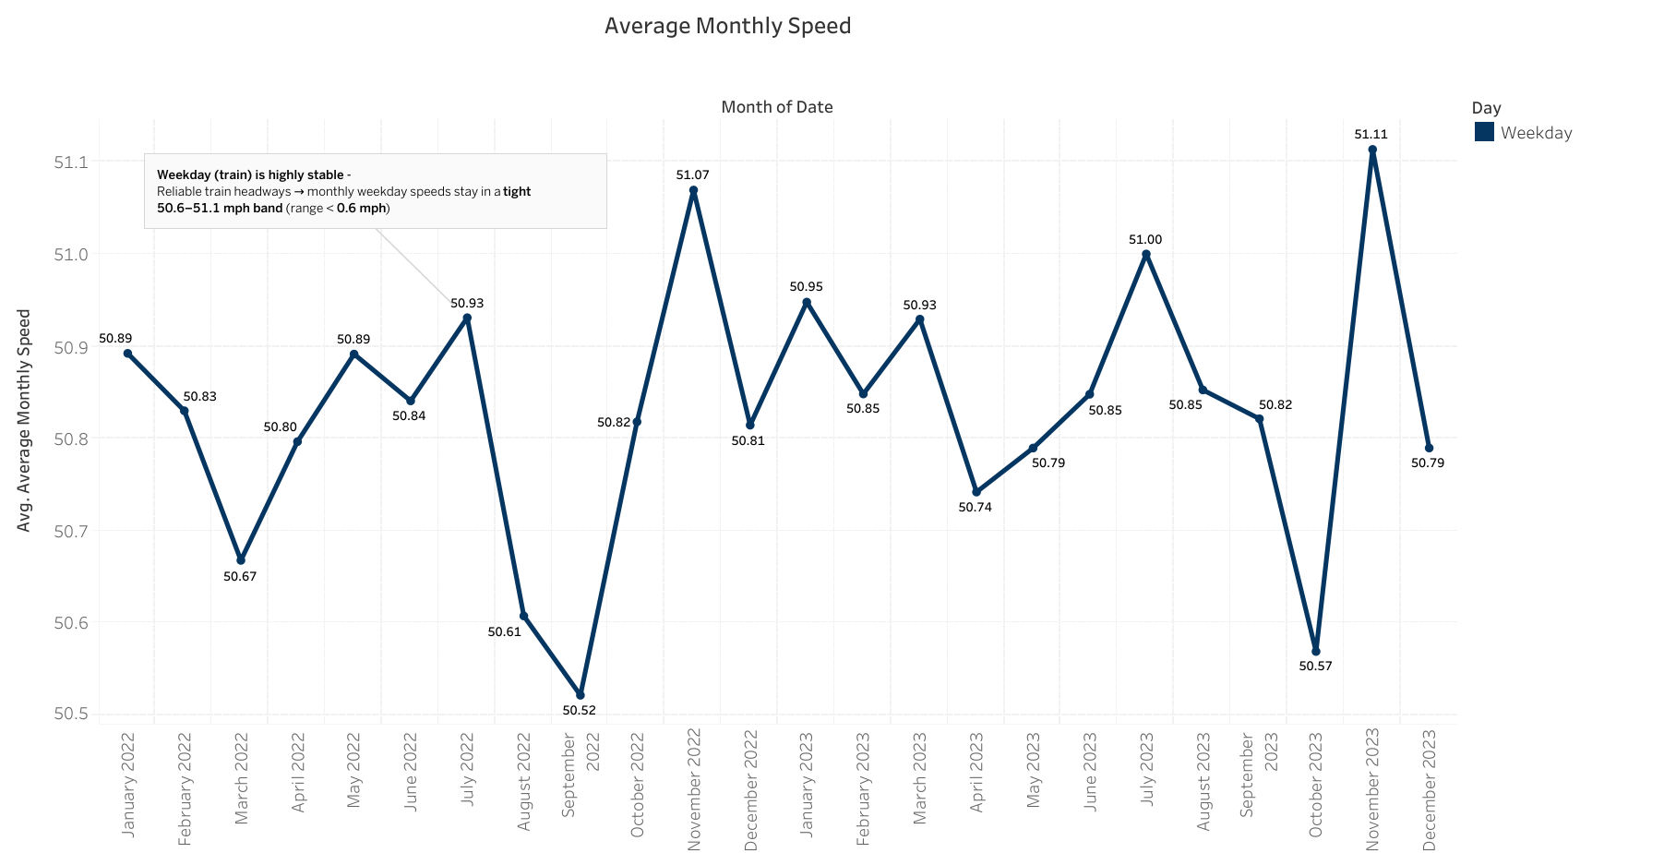
- Average Monthly Speed (Weekend) -Visual

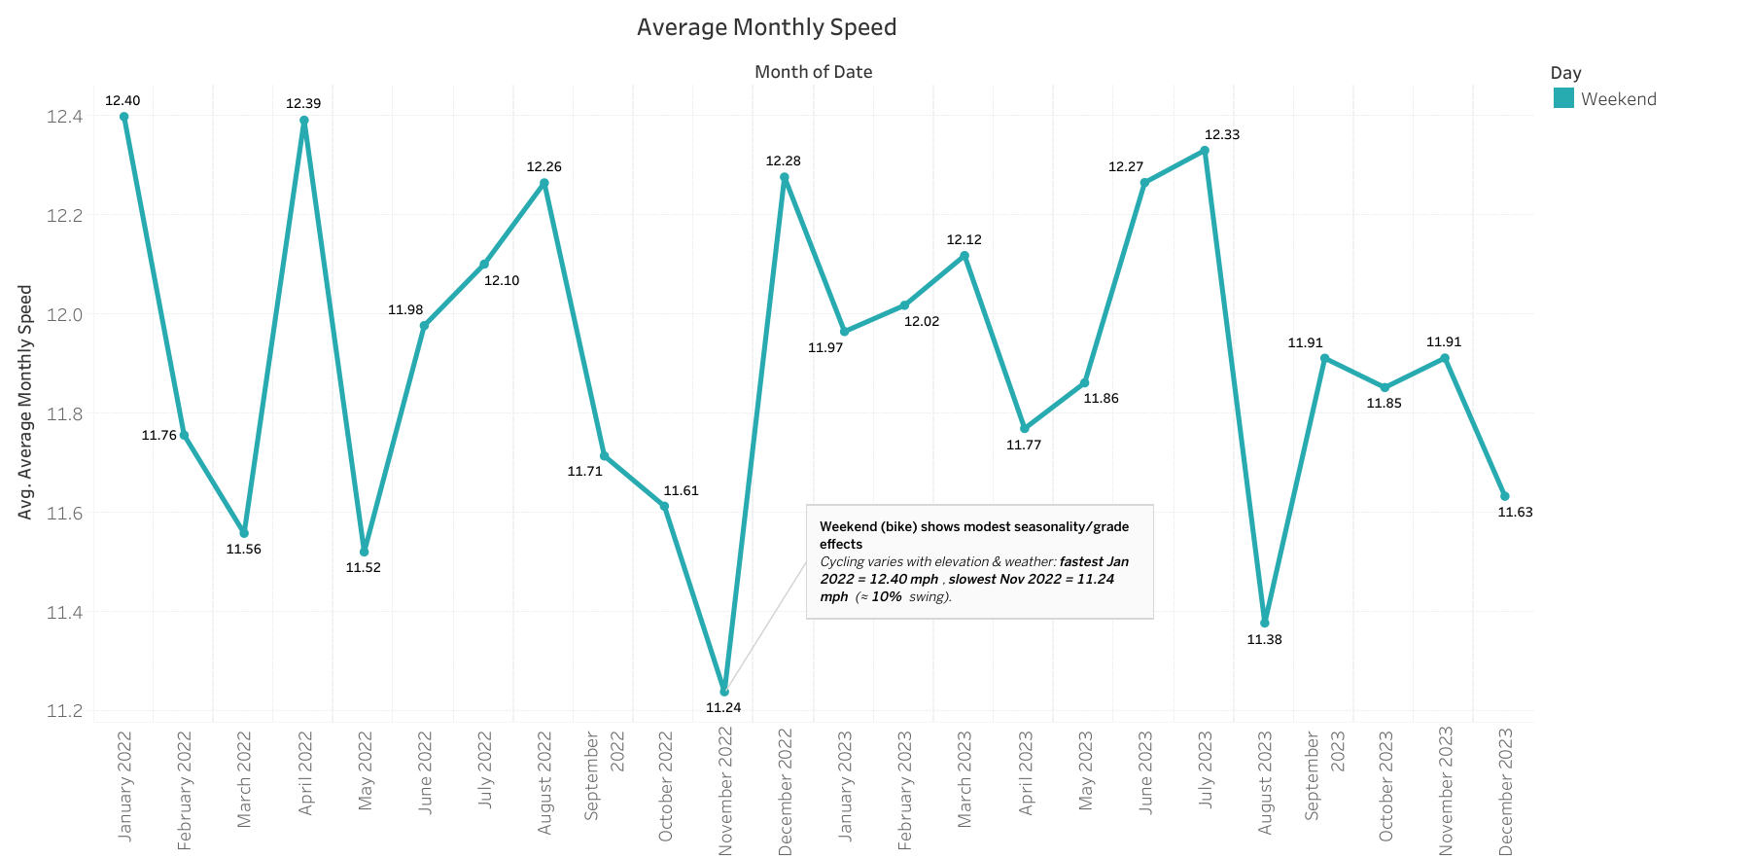
- Average Monthly Speed (Overall) -Visual

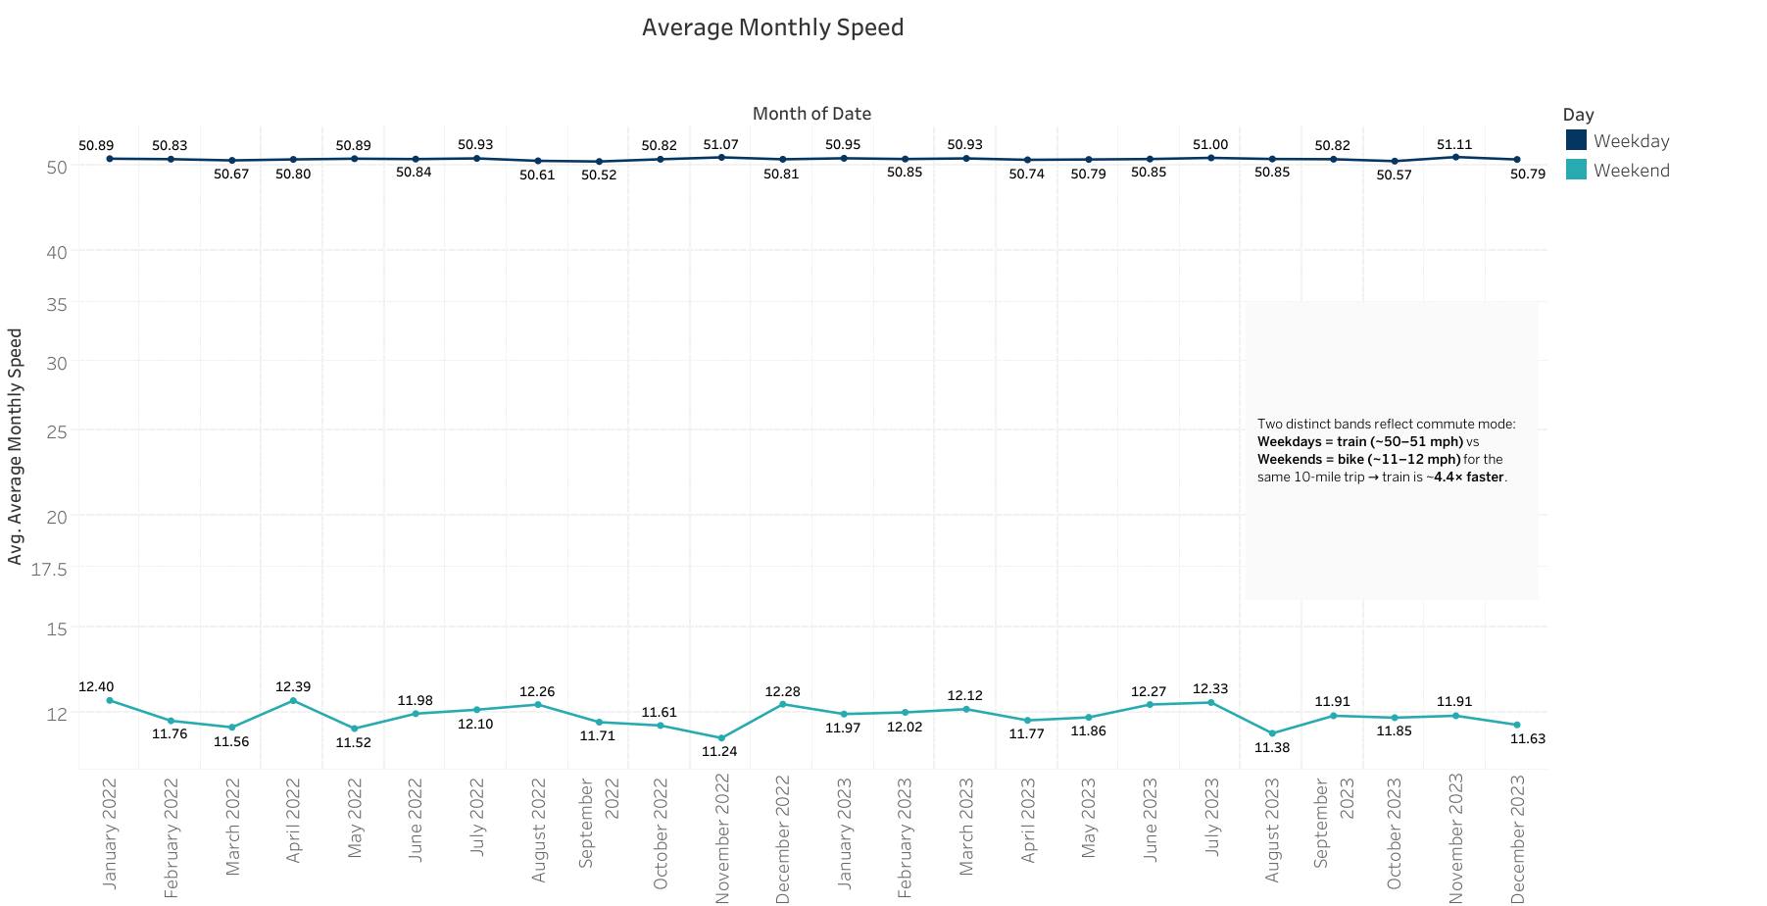

the Average Monthly Speed for each year–month combination (both weekdays and weekends). The weekday values cluster tightly around ~50.6–51.1 mph, while weekend values fluctuate more widely around ~11.2–12.3 mph.
Over the 24-month period, the average monthly speed splits cleanly by mode. On weekdays (train) the monthly harmonic-mean speed is remarkably stable, sitting in a tight 50.5–51.1 mph band (low 50.52 in Sep-2022; high 51.11 in Nov-2023; spread ≈ 0.59 mph ≈ 1.2%). On weekends (bike) it is much lower and more variable, ranging 11.24–12.40 mph (low 11.24 in Nov-2022; high 12.40 in Jan-2022; swing ≈ 10%). This yields a consistent ~4.3–4.6× speed advantage for the train (e.g., Nov-2023: 51.11 vs 11.91 mph). The weekday stability reflects reliable headways on the fixed 10-mile route, while weekend fluctuation likely follows elevation and weather. When weekdays and weekends are combined within a month, the overall monthly commute speed typically lands around ~25–27 mph.

3. Percentage Change Analysis
Month-to-month percentage changes were calculated to quantify volatility and identify significant shifts. The results are displayed below :
Formula used in Excel : (Open excel to see the overall MoM)
=IF(C4="", "", ((C5 - C4) / C4) * 100)/100
- C4 (previous month) = 25
- C5 (current month) = 26.5
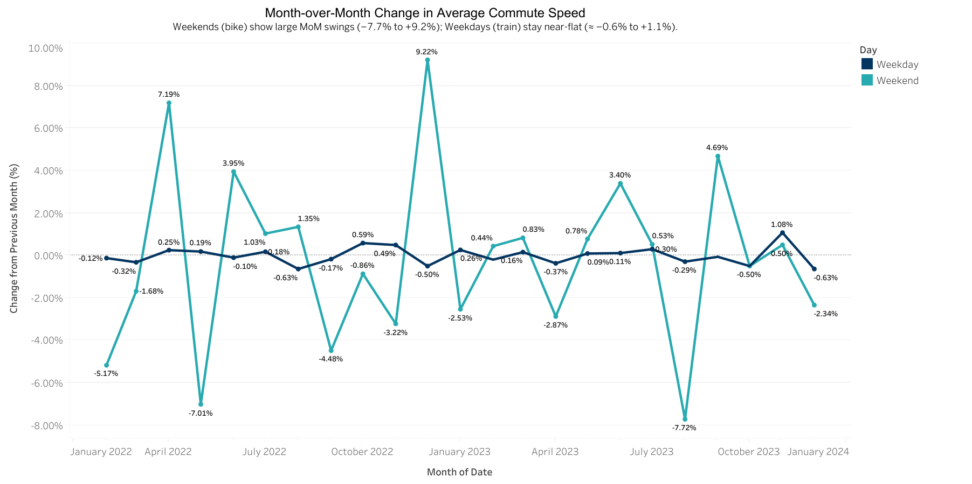
- Weekdays (Train Commute):
- Monthly variation is very small (mostly between -0.6% and +0.5%).
- This reflects train reliability: consistent headways and distance.
- Minor deviations (e.g., Jan 2023 +0.26%, Nov 2023 +1.08%) could be due to schedule changes, small delays, or data collection noise.

- Weekends (Bike Commute):
  - Variation is much larger (ranging from -7.7% to +9.2%).
  - Likely factors:
- Weather: Rain, snow, or heat slows cycling (e.g., Aug 2023 -7.72%).
- Elevation effect: Return trips slower → averages sensitive to small changes.
- Fitness or personal factors: Longer breaks, fatigue, or improved fitness could explain gains (e.g., Dec 2022 +9.22%).

- Narrative for CFO-style reporting:
Just as she would in financial reporting, she should highlight that:
- Train (weekday) commute is stable and reliable (low variance).
- Bicycle (weekend) commute is volatile and weather-dependent.
- Significant swings (±5–10%) deserve explanation, similar to revenue or cost fluctuations.

5. Conclusion
The commute speed data is a textbook example of a time series governed by multi-level seasonality in the absence of a long-term trend.
1. Primary Driver (Intra-Week Seasonality): The choice of transportation mode, determined by the day of the week, is the dominant factor.
2. Secondary Driver (Intra-Year Seasonality): Weather patterns throughout the year systematically influence the efficiency of both transportation modes, causing predictable fluctuations in the monthly averages.
3. Residual Variation – Daily Randomness: The remaining small inconsistencies stem from unpredictable daily events: minor train delays, personal energy levels, or environmental factors (e.g., wind, road conditions). These do not follow a systematic trend but contribute to short-term noise in the data.

Problem 2: Visualizing Proportions and Nested Proportions
Proportions (one chart): Visualize the overall proportions of key categories.
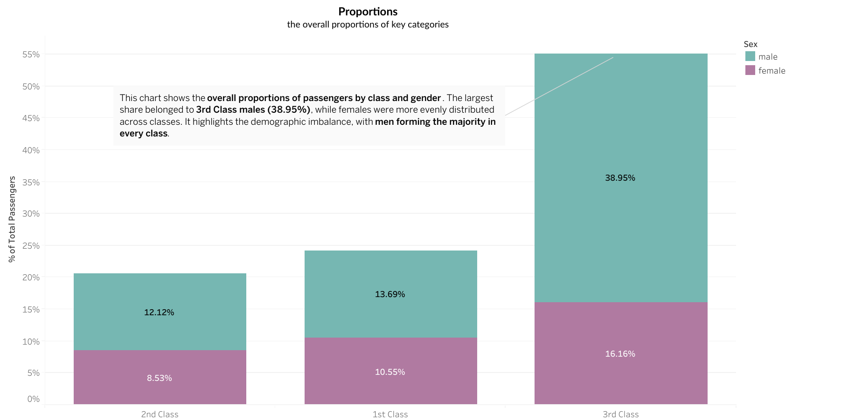
Findings from the Chart
- 3rd Class dominates the passenger distribution
  - Nearly 55% of all passengers were in 3rd Class.
  - Within this, the majority are male (~39%) vs. female (~16%).
- 1st and 2nd Class are much smaller groups
  - 1st Class: ~24% total (males 13.7%, females 10.5%).
  - 2nd Class: ~21% total (males 12.1%, females 8.5%).
- Gender imbalance across classes
  - In every class, males are the majority group.
  - The imbalance is most visible in 3rd Class, where men greatly outnumber women.
Nested Proportions (one chart): Represent proportions within proportions (e.g., survival rates within passenger classes). Self-Explanatory no explanation required.
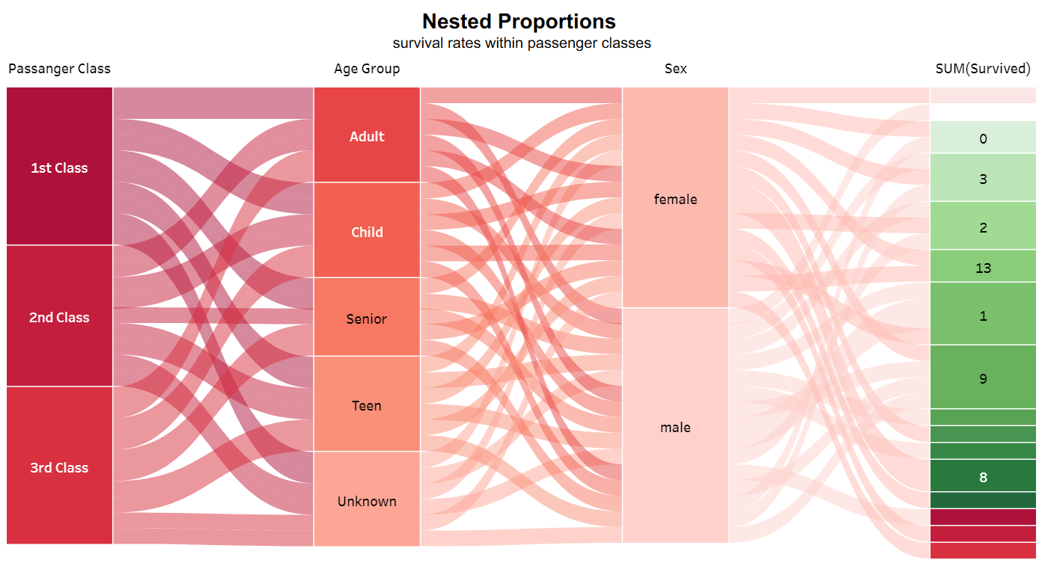
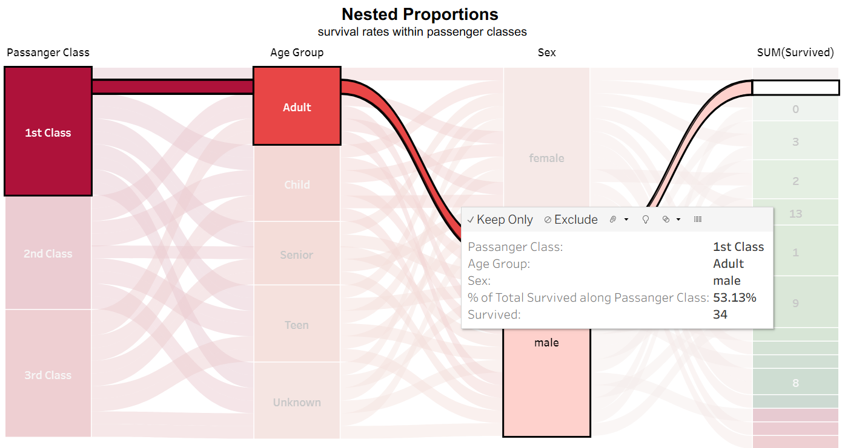
Findings:
1 Passenger Class and Survival
- Passengers in 1st Class had the highest survival rates.
- Survival drastically drops in 2nd and 3rd Class, with 3rd Class showing the lowest chances of survival.
2 Age Group Differences
- Children had comparatively higher survival rates, especially when traveling in 1st or 2nd Class.
- Adults and Seniors had lower survival chances across all classes, particularly in 3rd Class.
- Unknown age group appears smaller but shows some survivors.
- Teens had mixed outcomes but fared better than Seniors.
3 Gender as a Strong Determinant
- Females across classes had significantly higher survival rates compared to males, reflecting the “women and children first” policy.
- Males show much lower survival, even in 1st Class, highlighting a gender bias in survival outcomes.
4 Interactions between Class, Age, and Gender
- 1st Class Females had the highest probability of survival regardless of age group.
- Children in 2nd Class and 3rd Class also show some survival, though far fewer than 1st Class.
- 3rd Class Males were the worst affected, with survival rates extremely low.
5 Survival Counts (rightmost green column)
- The survival numbers range from 0 to 13 across different nested categories.
- The largest group of survivors (13) likely corresponds to female children/adults in 1st Class.
- Several categories (e.g., 3rd Class adult males, senior males) show near-zero survival.

Magnitude (one chart): Show the relative sizes of different categories.
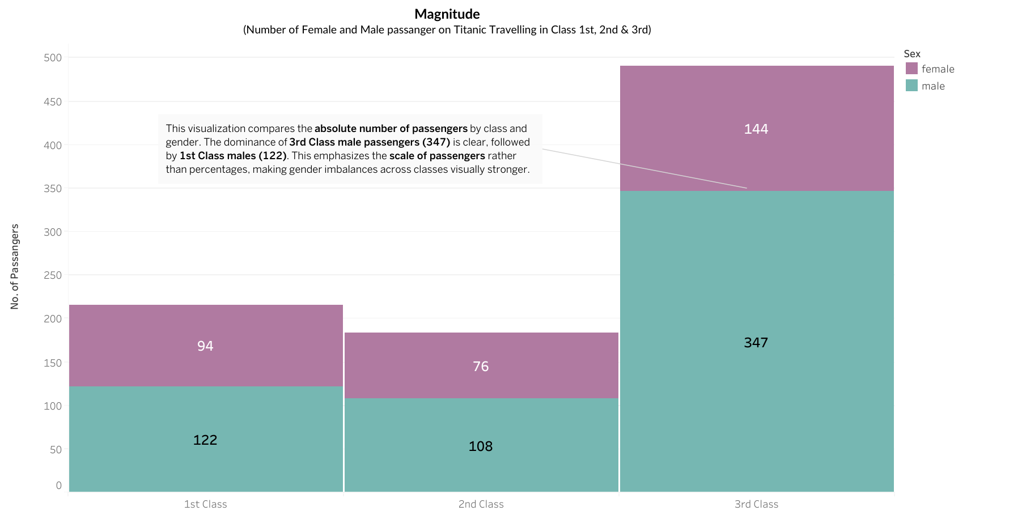
Findings
This chart displays the number of male and female passengers across 1st, 2nd, and 3rd Class. It clearly shows that:
- 3rd Class had the largest share of passengers, especially males (347 compared to 144 females).
- 1st and 2nd Class had fewer passengers overall, with a more balanced distribution between males and females.
- The gender imbalance is strongest in 3rd Class, where males far outnumbered females.

Problem 3: Visualizing Distribution
Histogram of Age: Show the age distribution of passengers. Choose an appropriate bin size to best represent the data. Self-Explanatory no explanation required.
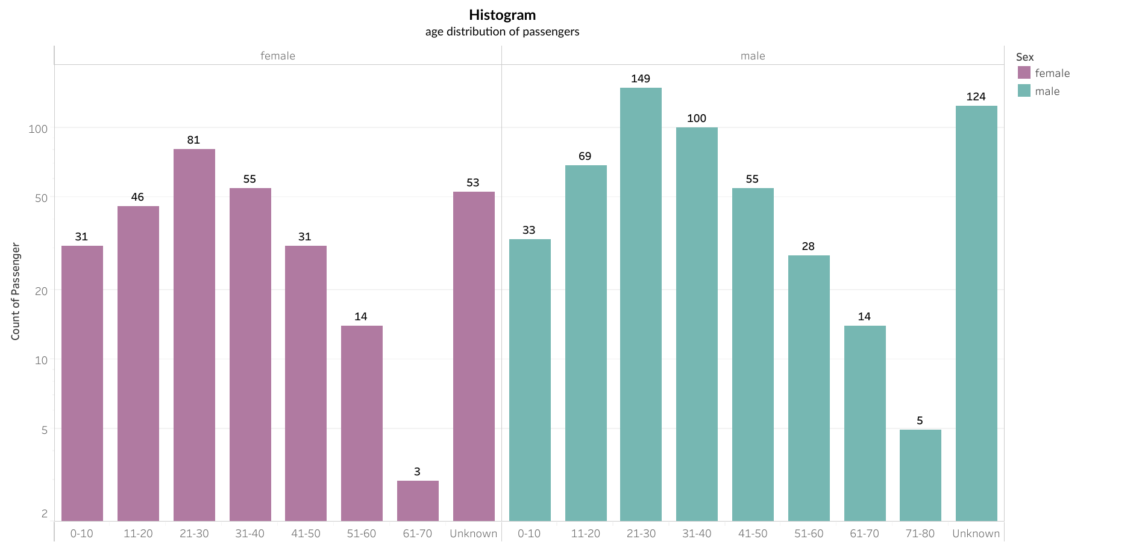
Findings
- The age distribution shows that most passengers were between 21–30 years old, especially males (149) and females (81).
- Male passengers dominate across almost all age bins, with particularly high counts in the 21–30 and 31–40 ranges.
- Female passengers also peak in the 21–30 range but are fewer in higher age bins compared to males.
- A notable number of passengers (124 males, 53 females) have Unknown ages, which may affect precise demographic analysis.
Cumulative Histogram of Age: Illustrate the cumulative distribution of the age variable.
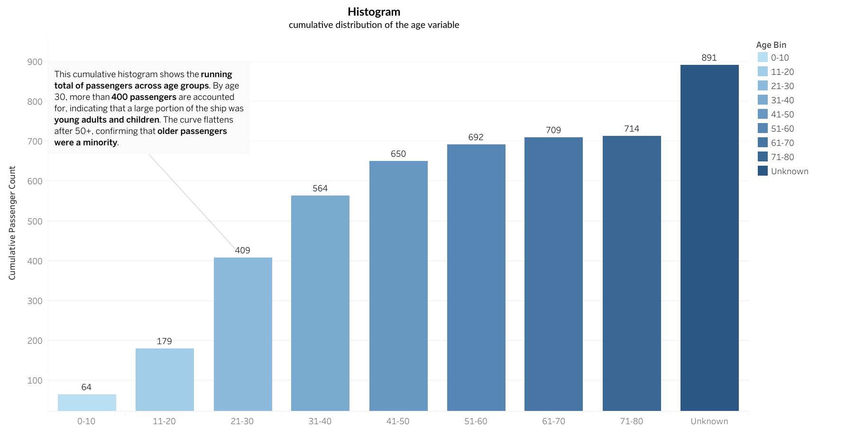
Findings
- The chart shows the cumulative passenger distribution across age groups.
- By the 21–30 bin, more than 400 passengers (~46%) are accounted for, highlighting that young adults formed a large portion of the Titanic’s passengers.
- The cumulative count continues to rise gradually until 71–80, reaching ~714 passengers.
- A big jump appears in the Unknown age group, adding ~177 passengers, which emphasizes missing age data as a significant factor.
Comparison of Age Distributions by Gender: Compare the age distributions of male and female passengers using one or two charts. You may use a pyramid chart or any other suitable chart type.
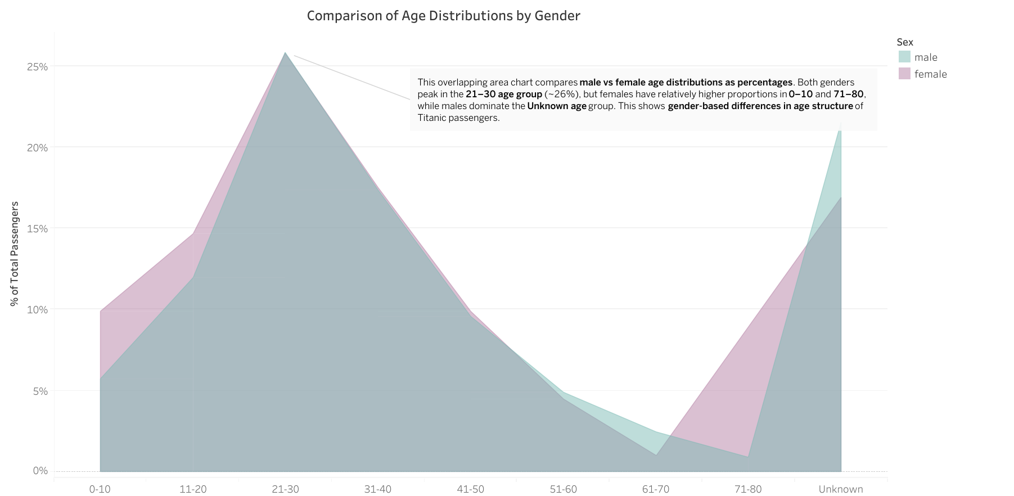
Findings
- The chart compares the age distribution of male and female passengers as percentages of total passengers.
- Both males and females peak in the 21–30 age bin, showing that young adults made up the largest group on board.
- For children (0–10), females had a relatively higher share compared to males.
- For older age bins (61+), the distributions thin out for both genders, with females slightly more represented in 71–80.
- The Unknown category is also significant, with males making up a larger share of this missing data group.
How Did I used AI
I used AI (ChatGPT) to guide my data visualization process in Tableau. It helped me decide which chart types were most appropriate, create calculated fields (e.g., bins, percentages), and write clear annotations for each visualization. This streamlined my workflow and improved the clarity of my analysis.

